**Project Description and Features:**

The Project is a simple paint project which draw geometric shapes and Edit them, the user can choose the Shape he wants to draw from (Circle, Ellipse, Line Segment, Square, Rectangle and Triangle).and can edit them from an Edit Menu which is (resize,Move,Copy,Delete)

The user can choose the color of the shape from the color panel.

The user can choose if the shape is filled with color or not.

The user can Undo and redo up to 20 different processes.

**Teamwork:**

Ahmed Aly: The whole GUI –Saving and Loading-fill color

Ramy Essam: Move – Copy-Resize -Select

Mostafa Magdy: Undo and Redo

Khaled: Draw –Color

**Data Structure:**

Arraylist<Shapes>: it carries all the shapes.

Hash Maps: a hash map for its shape which carries the properties of the Shape.

Stack: a stack which when undo is pressed, the stack carries the process which has been undo and when redo is pressed the stack pops the process.

**User Manual:**

1. Choose The Shape you want by pressing the button of that shape.
2. Draw on the drawing panel by mouse dragging.
3. Press the select button if you want to edit the drawn shape.
4. Choose the shape you want by pressing anywhere inside the shape.
5. Choose from the edit menu or by pressing right click the process you want to do.
6. Select the point where you want the process to happen.
7. Press Undo button to undo.
8. Press the redo button to redo.
9. Press the fill color button if you want to fill the shape with color.
10. You could choose from the file menu to open or save the drawing ,by pressing the open or save button a file chooser appears and asks you to choose where you want to save or the file you want to open and choose the filtype whether its json or xml .

**Sample runs:**

Opening the program:

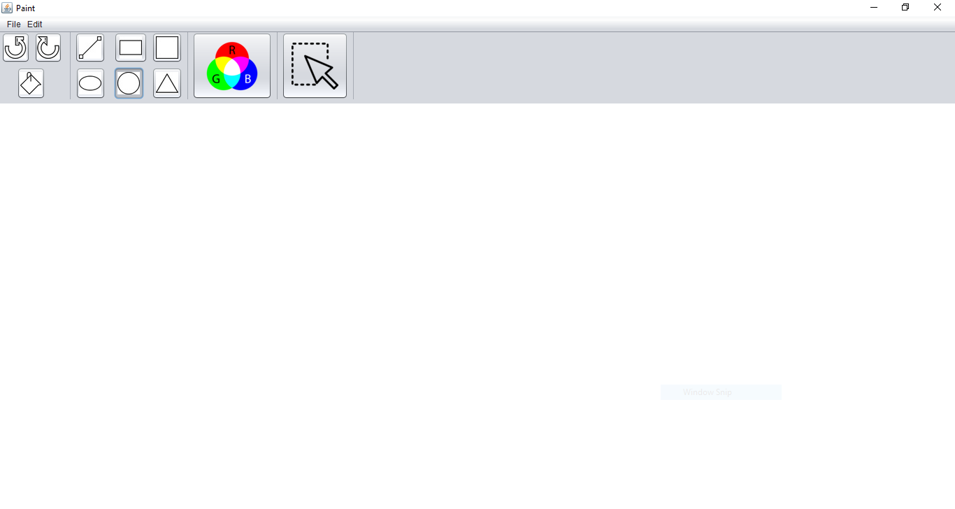

Drawing a Circle:

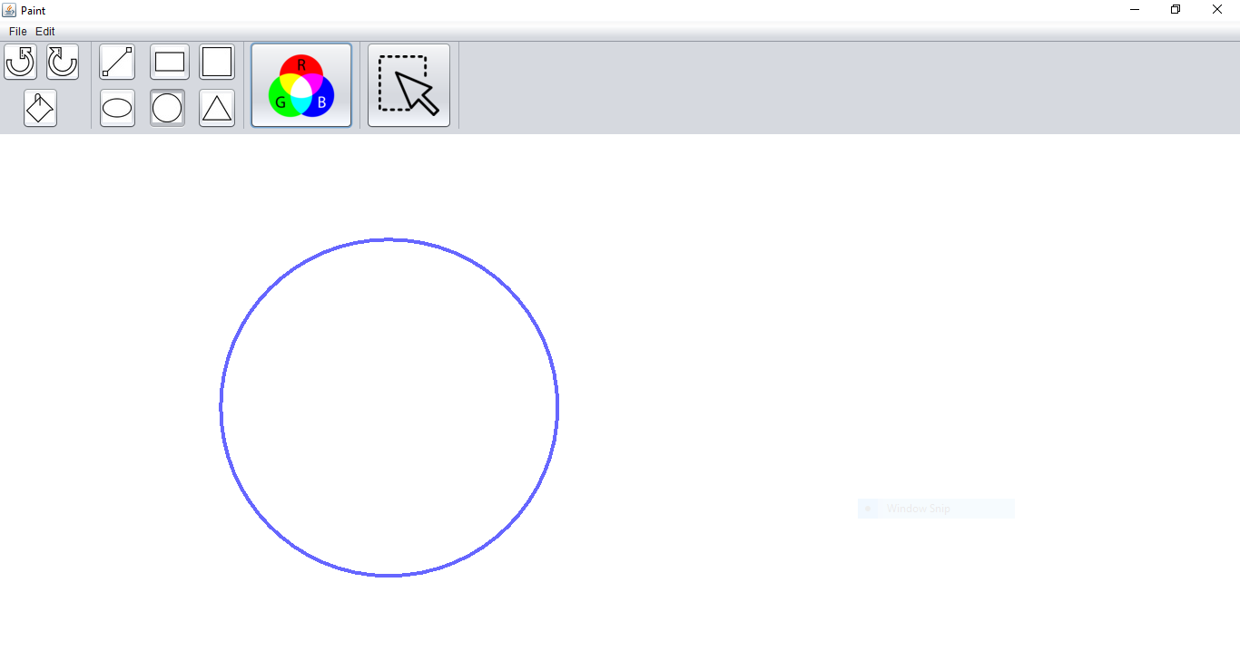

Selecting the square to edit:

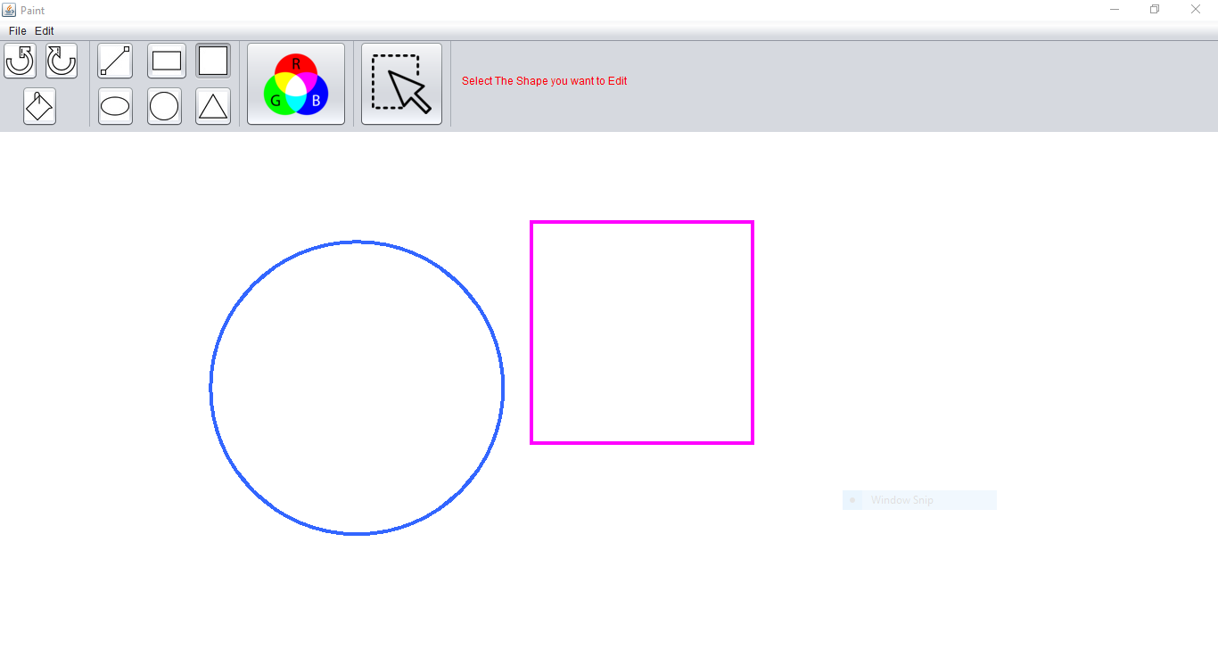

Coping the square:

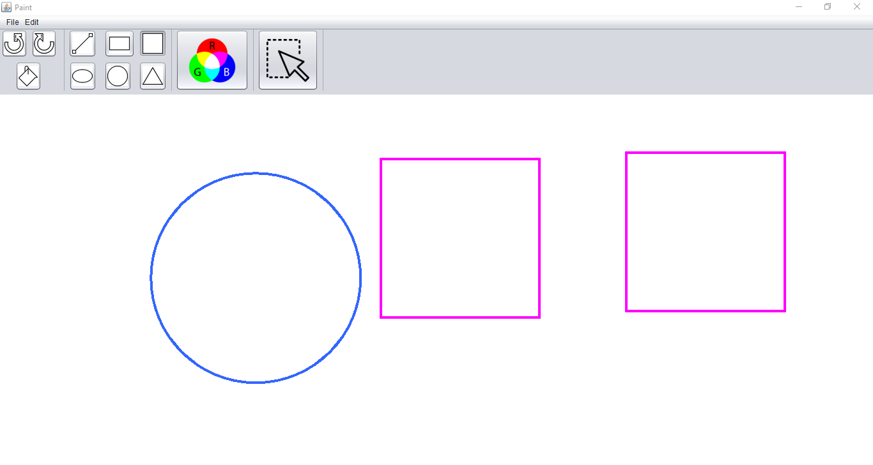

**Class Diagrams:**

**UML:**

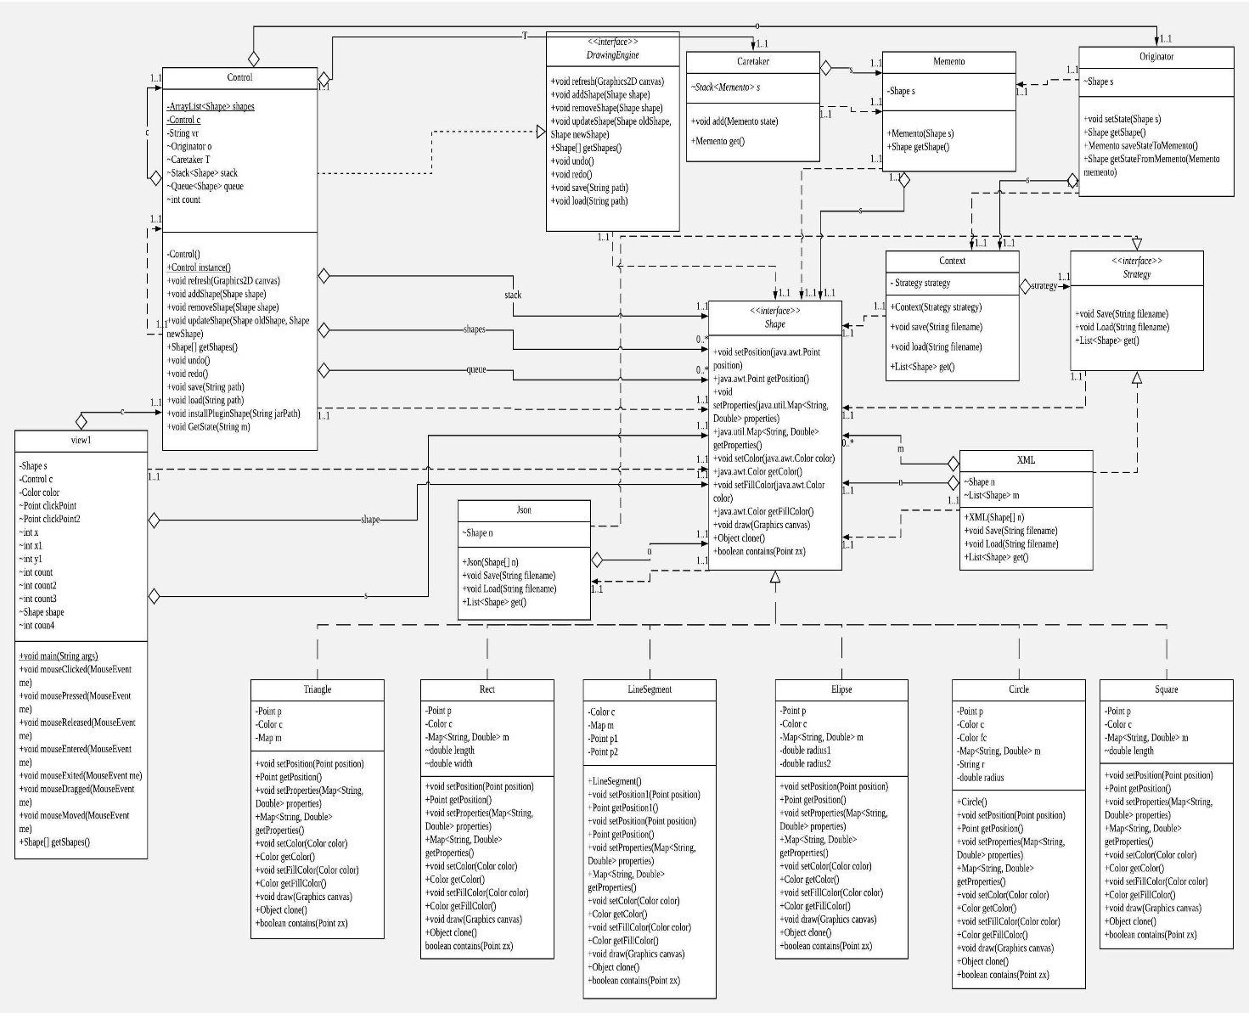

**Use Case:**

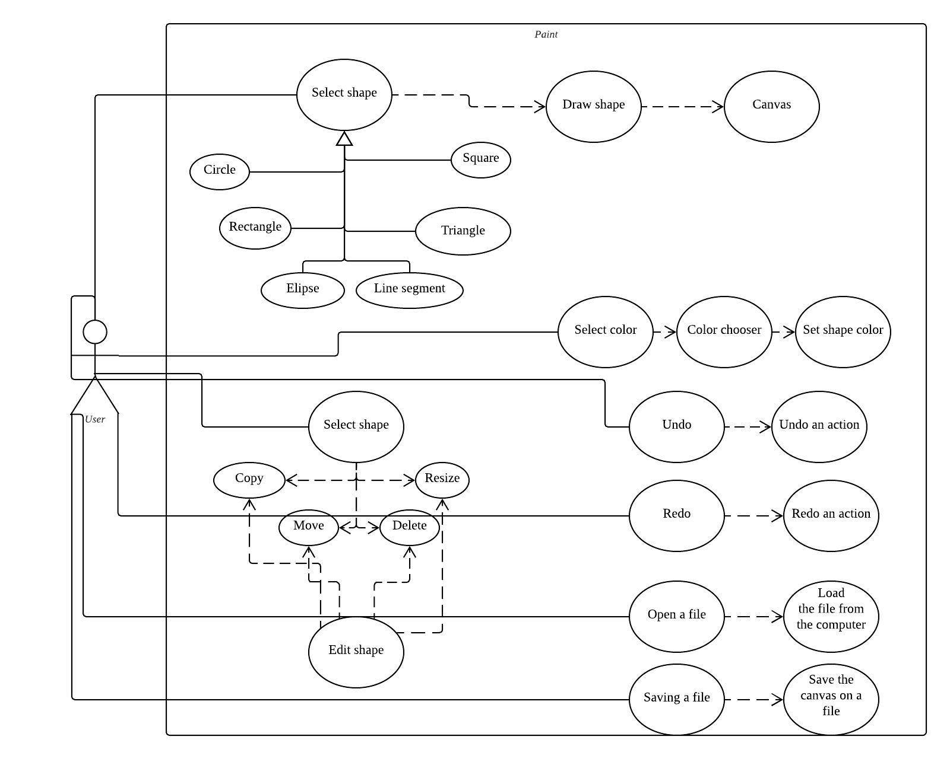

**Sequence Diagrams:**

Drawing a circle:

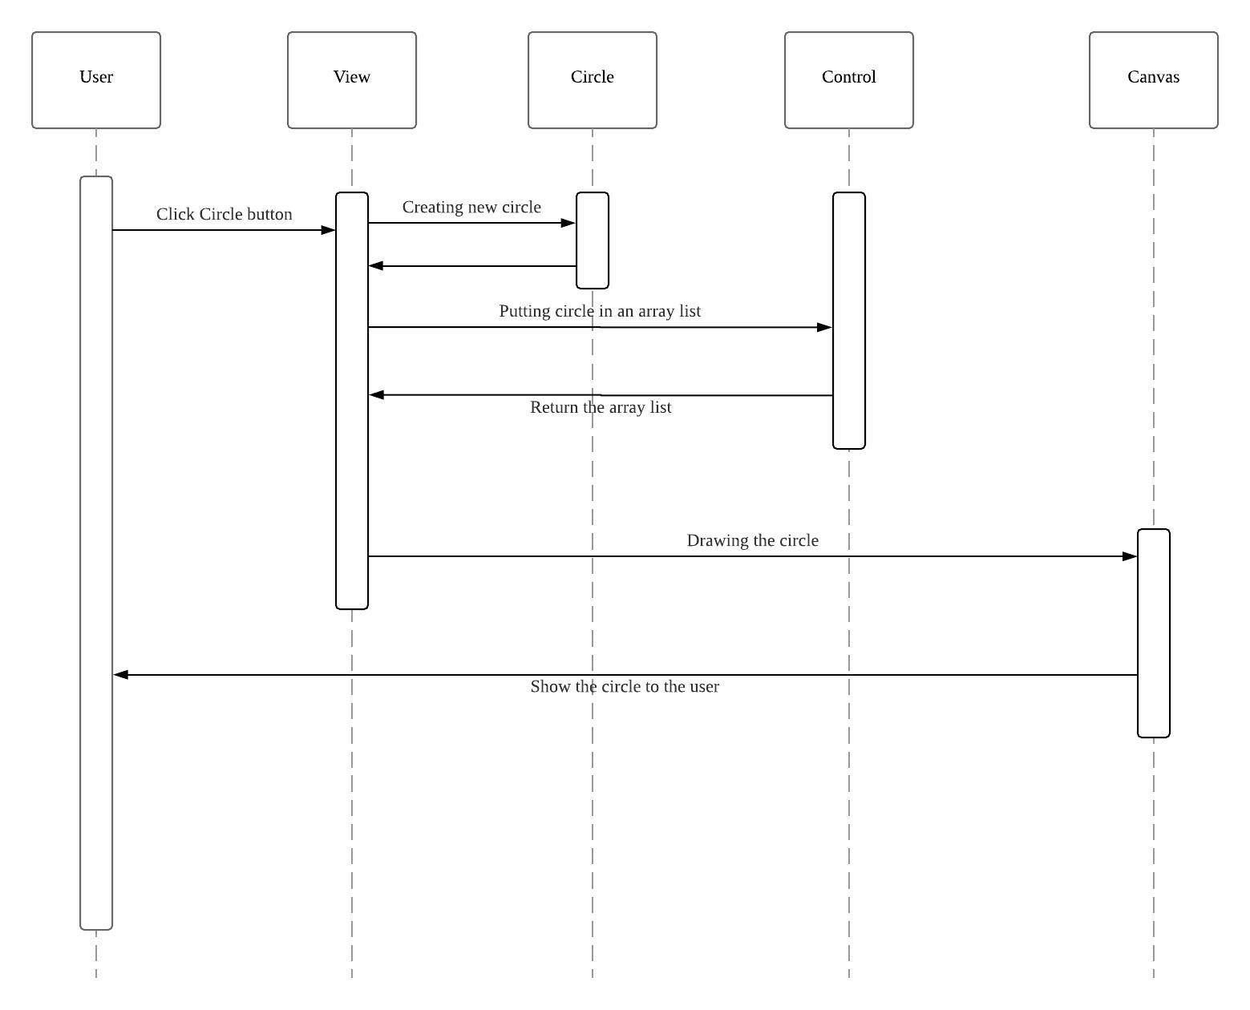

**Editing an Ellipse:**

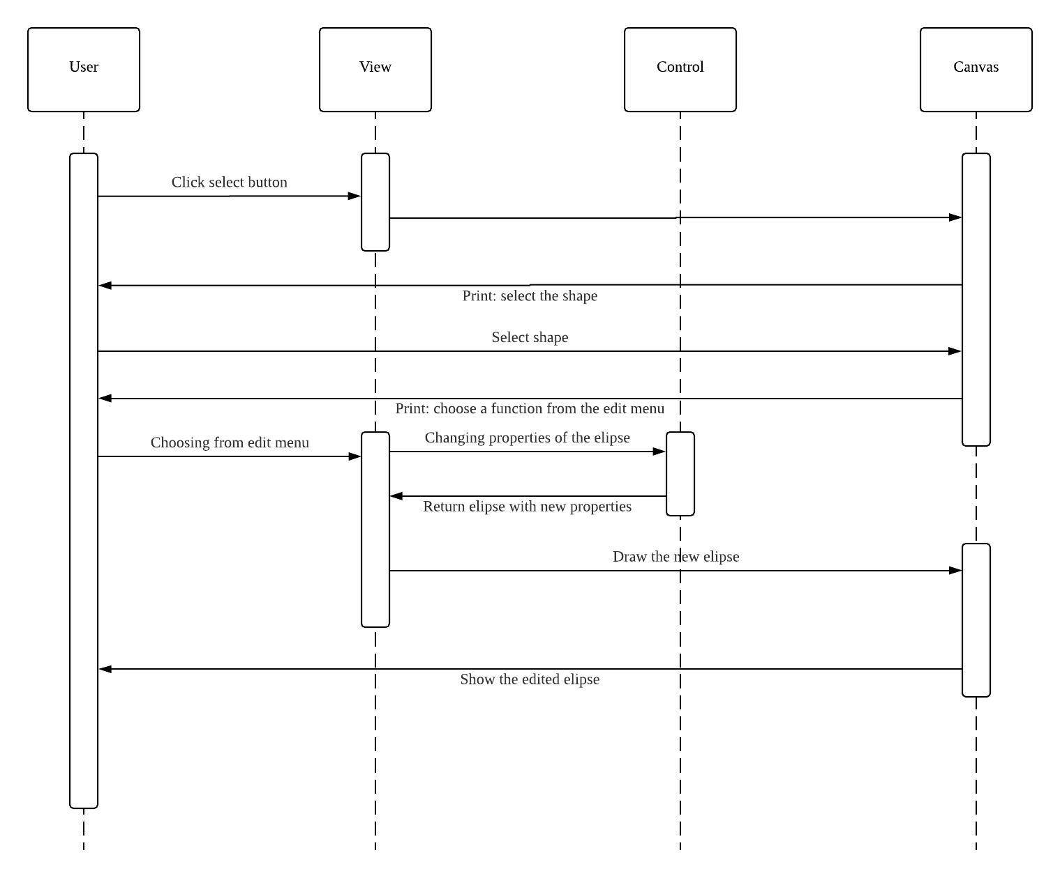

**Saving in a json file:**

